Team 11
EMPLOYEES SATISFACTION SURVEY REPORT
SOFTWARE MEASUREMENT AND ANALYSIS

Create by: Team 11
5/1/2012

Table of contents
1. Introduction 2
1.1. Survey purpose 2
1.2. Purpose of this document 2
1.3. Methodology 3
2. Employees Satisfaction Measurement 3
2.1. Employees Satisfaction Categories 3
2.2. Employees Satisfaction Index (ESI) 4
3. Analysis Employees Satisfaction Survey 4
3.1. Summary survey responses 4
3.2. Detail assessment 6
4. Recommendations 6

List of figures
Figure 1 5
Figure 2 5
Figure 3 6

List of tables
Table 1 4
Table 2 6
Table 3 6
Table 4 6
Table 5 7

Introduction

Survey purpose
Software Engineering Department Employee Satisfaction Survey of the ABC Systems from November, 2009. The purpose of the survey was to:
- Measure employee perceptions of the work environment
- Identify job satisfaction levels
- Identify areas of strength and opportunities for improvement
The statements based on a Strongly Agree, Agree, Neutral, Disagree, Strongly Disagree scale
The survey gathered information about employee satisfaction in six main areas:
- Working Environment
- Communication
- Chance
- Job Security
- Democratization
- Morale
The survey also offered opportunities for respondents to provide their own ideas and comments

Purpose of this document
This document is to specify the method to analysis employee survey data that provided by employee and specify the strengths and weaknesses in this survey.
The document also shows the areas for improvement for the survey.
Through this document we will suggest recommendations that would you make to improve the survey.
The employees satisfaction survey data in this document assignment will be collected from “Viking_Project_Team_Morale_Survey_Data.xls”

Methodology
We base on Employees Satisfaction Index (ESI) for assessment employees satisfaction and to help to help identify specific actions to improve satisfaction and productivity at ABC systems

Employees Satisfaction Measurement

Employees Satisfaction Categories
No. | Employees Satisfaction Category | Description | Survey Question
1. | Working Environment | The rooms, equipment, organization, comfort on the job | - I feel informed about changes that affect me  4. My department is a great place to work  5. ABC Systems is a great place to work  6. My project is a great place to work  10. I have the tools and resources that I need to get my job done  12. I would recommend ABC Systems to friends as a great place to work
2. | Communication | Teamwork/ Colleagues  Communication in relationships, relation between colleague together, employees with boss and another stakeholders | 9. There is cooperation between the departments in the company
3. | Chance | Recognition / Reward/ Advancement/ Promotion  Training/ Mentoring  Supervision/ Involvement | 1. I see career growth and advancement opportunities for myself at ABC Systems  3. I am provided with opportunities to broaden my skills and knowledge  15. I know how my work contributes to the success of ABC Systems
4. | Job Security | The stability of the job (looking for another job outside/ working long – term with team, …) | 7. I am currently looking for another job outside of ABC Systems  11. I have had the training I need to get the job done
5. | Democratization | Be treated fairly  Have value in team  Workload/ Resources | 8. I am empowered to make decisions  13. I have access to the information that I need to do my job well  14. My opinions are valued by my project team
6. | Morale | Job satisfaction  Mission/ Motivation | 16. I take pride in my work
Table 1

Employees Satisfaction Index (ESI)
We will collect satisfaction index data based on 6 key aspects that is provided in Section 1, then calculates employee satisfaction index (ESI) in ABC System.
The satisfaction index of the key aspects is calculated by the total number % (Strongly Agree and Agree) at each of statement in key aspect.
The satisfaction index of the key aspect is considered positive when total number % (Strongly Agree and Agree) of key aspect more than 65%
- ESI >= 65% - is considered positive
- ESI < 65% - is considered negative
Employee Satisfaction Index (ESI) formula:
Total % positive of key aspects
ESI =
#Number of key aspects

Analysis Employees Satisfaction Survey
References attachment: “K15T1-Team11-Team Assignment12.xls”

Summary survey responses
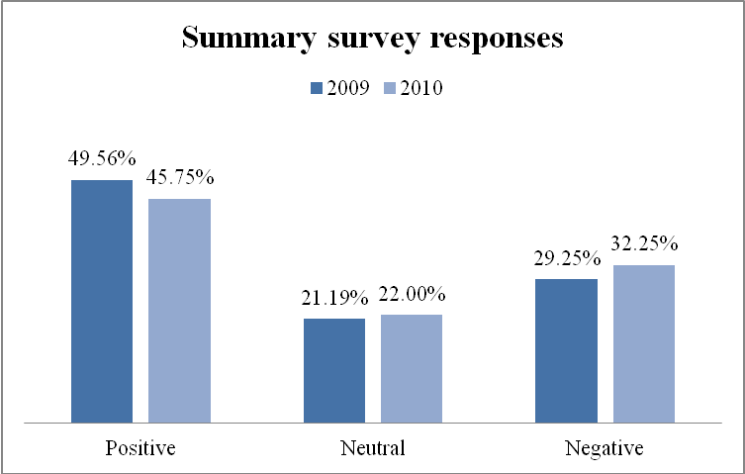
Figure 1
Picture above describe satisfaction rates in work of employees in 2 years with 3 index. Positive (satisfied), neutral and negative (unsatisfied).

- In 2 years. The employees are satisfied with their work but rate is not high and it tends to decrease.
- Unsatisfied rate in 2010 is higher than 2009.
- The employees feel ambiguous in their work are increase.
- This is not good with satisfied rate is low and decreasing in future.

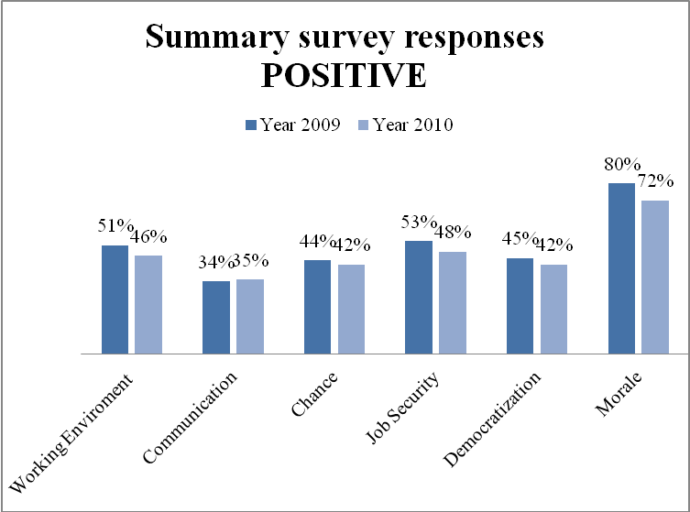
Figure 2
 | Year 2009 | Year 2010
Working Environment | 51% | 46%
Communication | 34% | 35%
Chance | 44% | 42%
Job Security | 53% | 48%
Democratization | 45% | 42%
Morale | 80% | 72%
Table 2

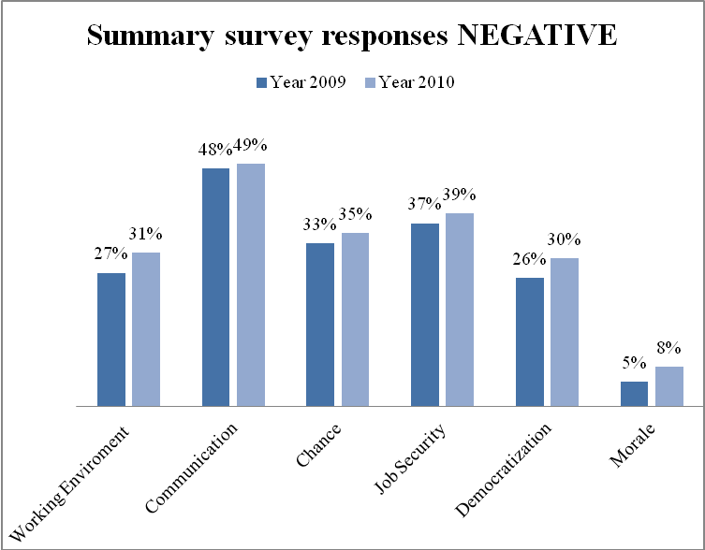
Figure 3
 | Year 2009 | Year 2010
Working Environment | 27% | 31%
Communication | 48% | 49%
Chance | 33% | 35%
Job Security | 37% | 39%
Democratization | 26% | 30%
Morale | 5% | 8%
Table 3

ESI in 2009 | 51% + 43% + 44% + 53% + 45% +80%  = 52.67%  ESI =  6 | ESI is 52.67% (< 65% ) – ABC system isn’t meet most employees satisfaction
ESI in 2010 | 46% + 35% + 42% + 48% + 42% + 72%  ESI =  = 47.5%  6 | ESI is 47.5% (< 65% ) – ABC system isn’t meet most employees satisfaction
Table 4

Detail assessment
References attachment: “K15T1-Team11-Team Assignment12.xls”
Based on the above analysis, the areas for improvement for the survey is (all key aspects) and add some areas:
No. | Employees Satisfaction Category | Description | Survey Question
1. | Working Environment
2. | Communication
3. | Chance
4. | Job Security
5. | Democratization
6. | Morale
7. | Health & Hygiene
8. | Employees care | Insurance, …
9. | Working Culture | Travel, recreational activities, …
Table 5

Recommendations
- For survey
- Should add a section below each question for survey participants to write their comment of this question.
- Should add some questions about health, entertainment .. in survey.
- For company
- The satisfaction of employees in company are low, less than 50% and decreasing in future but morale is high.
- The neutral rate is increasing and at high threshold >20%.
- The management should find out their employees carefully, begin by asking the area with high neutral rate in company to see what they need, what they want and their desired.
- Find out and improve working environment, communication, chance to increase satisfaction. Focus on communication.
- Morale is high but is decreasing, management should give solution to keep it high and increase in future.

